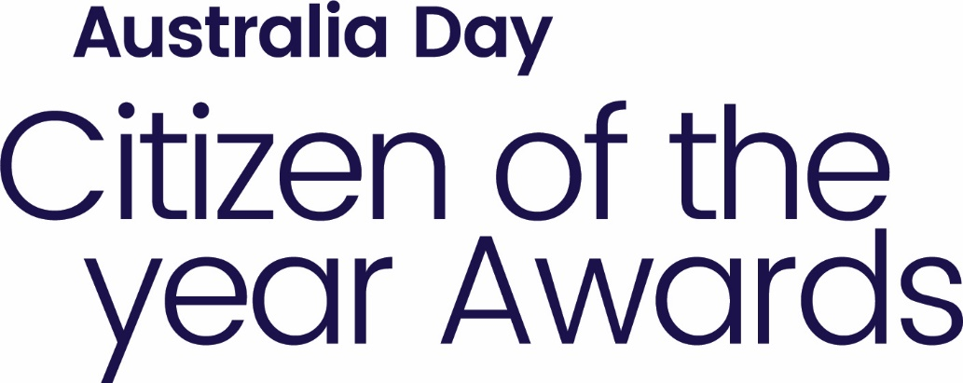

Nominate them in the 2022 Citizen of the Year Awards!

CATEGORIES:

Citizen of the Year
To be eligible, the person must be an Australian Citizen.

Young Citizen of the Year
To be eligible, the person must be an Australian Citizen under 30 years of age on January 26, 2021.

Community Event of the Year
This is presented to the person/group who has staged the most outstanding community event during the past year.

Complete the nomination webform on our website or return completed form
before 24 December 2021 to:

Any West Arnhem Regional Council office
EMAIL: info@westarnhem.nt.gov.au

PHONE: (08) 8979 9465

Do you know someone
who makes your community a better place?

AUSTRALIA DAY AWARDS
NOMINATION FORM
Please provide as much information as possible. Additional documents may be attached providing further information of testimonials of achievement.

AWARD CATEGORY: (please tick)
☐ CITIZEN
☐ YOUNG CITIZEN
☐ COMMUNITY EVENT

NOMINEE DETAILS (person who is being nominated)
Name: ____________________________________________________
Address: __________________________________________________
Phone: __________________________________ Date of Birth: ___/___/____
Email: ____________________________________________________

HOW HAS THE PERSON/ORGANISATION CONTRIBUTED TO THE COMMUNITY?
Please provide as much information as possible. Additional documents may be attached providing further information.
_________________________________________________________________________________
_________________________________________________________________________________
_________________________________________________________________________________
_________________________________________________________________________________
_________________________________________________________________________________
_________________________________________________________________________________

PLEASE LIST ANY OTHER SIGNIFICANT CONTRIBUTIONS AND/OR ACHIEVEMENTS:
_________________________________________________________________________________
_________________________________________________________________________________

NOMINATOR DETAILS (person making the nomination – your details)
Name: ____________________________________________________
Address: __________________________________________________
Phone: ___________________________________________________
Email: ____________________________________________________

Please return completed form before 24 December 2021 to:

ADDRESS: Any West Arnhem Regional Council office
EMAIL: info@westarnhem.nt.gov.au

PHONE: (08) 8979 9465

